In this lab, we will explore connecting options for the VM we created in myvpc in previous lab. We will also create firewall rules regarding this

First go to public vm and login to it (This will not connect and give error)

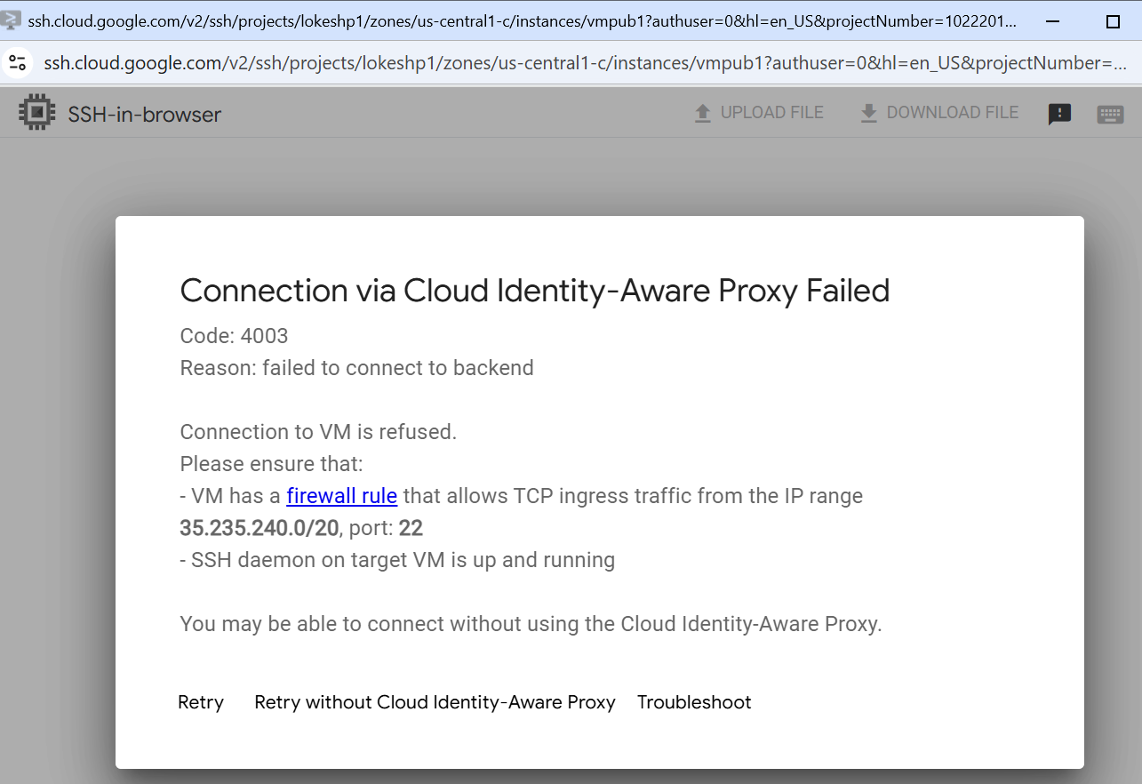

Now go to VPC page and go to Firewall

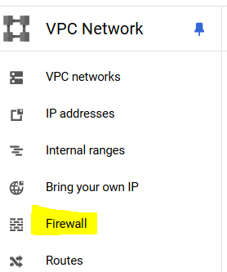

Here you will see, all rules are related to “default” vpc only

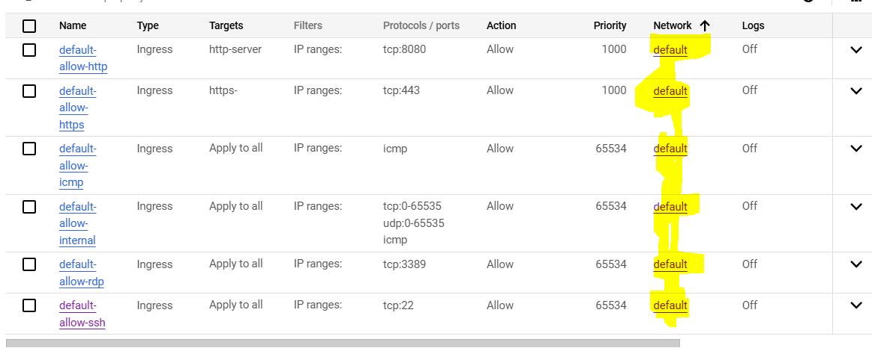

So we will create new rule for myvpc, click Create firewall rule

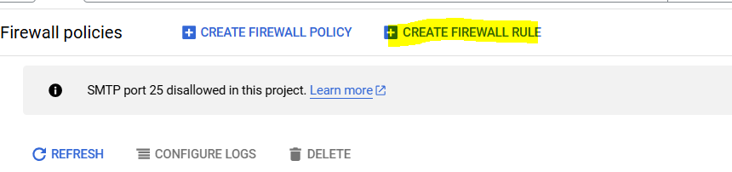

Give rule a name and select myvpc

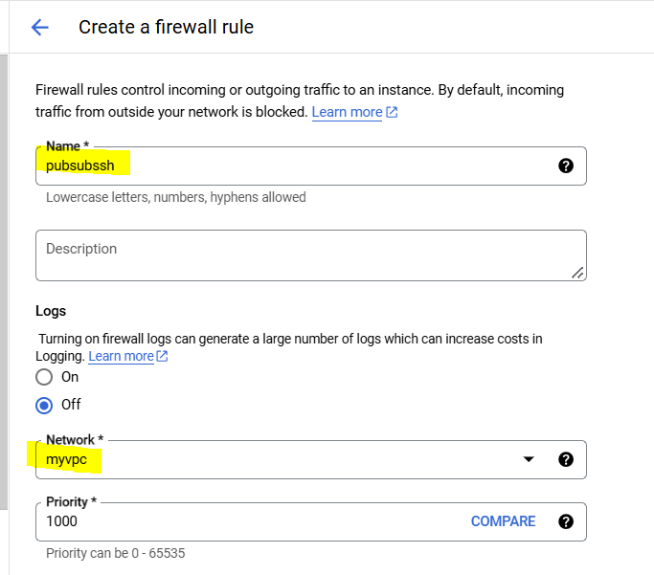

Select for All instances in the network option (Also there is an option for tags, this will apply the rule for the VM with specific tags)

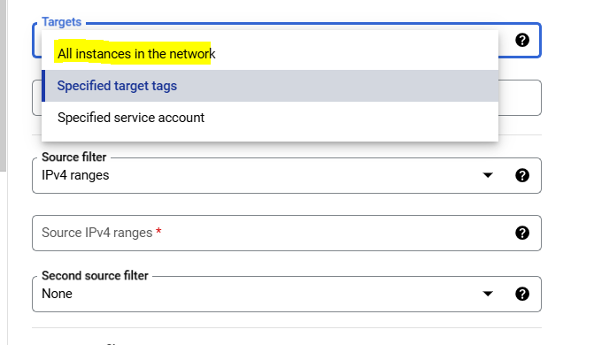

Enter 0.0.0.0/0 for source Ip and port number as 22, then click create

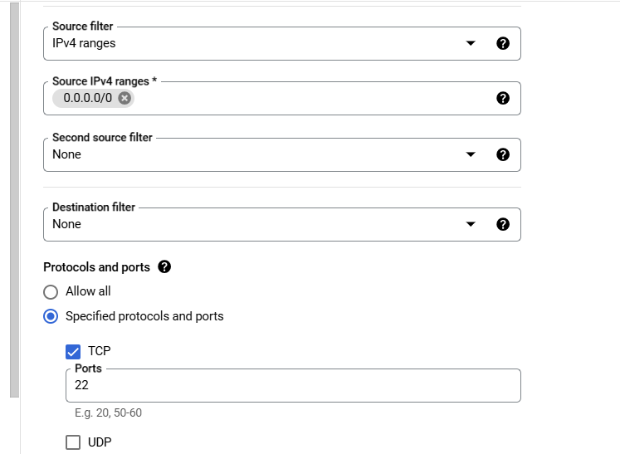

Check Firewall rules list again, now it should show the rule which we created above

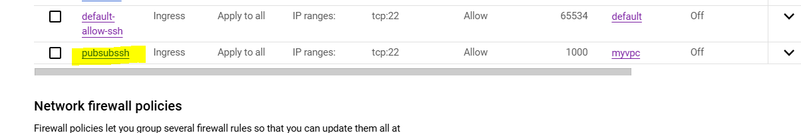

Now try connecting to pubvm, and this should connect this time

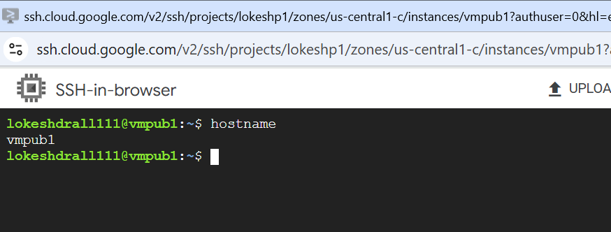

Now try connecting to prvvm (VM which we created in private subnet)